Leviticus – Session 1
Introduction to the book; Sacrifice (1)

- Why study Leviticus?

Reasons to study the book:

1 All scripture is God-breathed and useful for teaching, rebuking, correcting and training in righteousness (2 Tim 3:16).

2 Leviticus is to us, just as much as it was to ancient Israel, a revelation of the character of God and how we can know God

3 Leviticus is a gospel book.

4 Essential background reading for reading the NT. Out of the 39 books of the OT, 6th most quoted.

- Title

Leviticus = Title from LXX (matters concerning the Levitical Priesthood)
- much about the Priesthood (Aaron and descendants)
- but it is just as much for and about all of Israel

Hebrew Title (wayyiqra) means ‘And he called’
- it is a book about the continued theme of God’s revelation

‘The Lord said to Moses…’ – well over 30 times - most often, ‘say to the Israelites…’

- Setting in the Pentateuch (the five books of Moses)

Part of the great narrative of God redeeming a people for himself

Follows straight on from Exodus
- 2nd half of Exodus – Israel camped at Sinai
- clearly a sinful people (evidence: the golden calf); threatened with destruction
- grace – nation preserved; tabernacle built
- climax of Exodus – glory; Moses cannot enter

Read on – Lev 1:1-2 – offering – root ‘to draw near’

- Exodus – God’s action/God’s approach to his people: how he brought them near

- Leviticus – Israel’s response/the people’s approach to God: how to stay near

- Structure

Chapters | Contents
1-7 | Instructions for Sacrifice
8-10 | Institution of the Priesthood
11-16 | Regulations concerning Uncleanness and its Treatment
17-27 | Commandments for Holy Living

or more simply:

1- 16 Being a Royal Priesthood with privileged access to God

17-27 Being a Holy Nation with a corporate life that reflects the character of God

Another way of seeing the structure: (from www.thebibleproject.com)

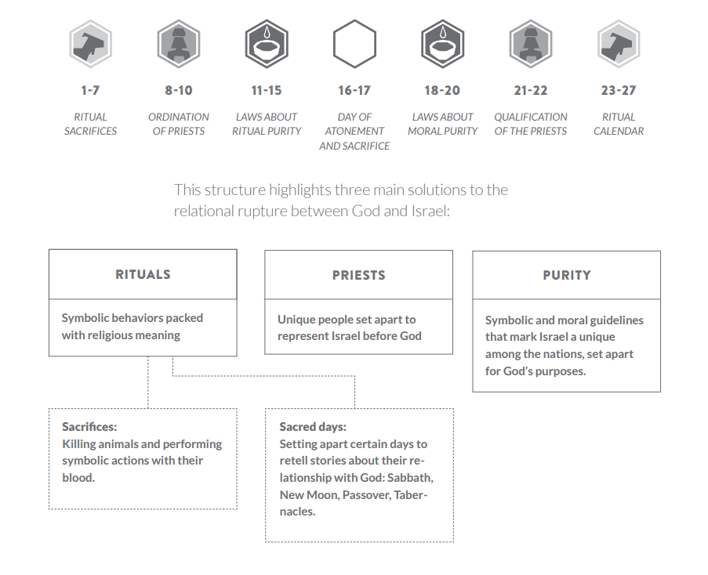

- Sacrifice – a major theme

ch 1-7 – the sacrifices
ch 8-10 – priests: the people who administer the sacrifices
ch 11-15 – uncleanness that can only be removed by sacrifice
ch 16 – day of atonement – sacrifice is central
ch 17 – treating blood as sacred because of its significance in the sacrifices
ch 21-22 – more about the people who administer the sacrifices
ch 23-24 – the ritual calendar – regular occasions when sacrifices must be made

Why sacrifice?

- Elements of thanksgiving, consecration and communion (all implied)

- The explicit purpose – ‘to make atonement’ (1:4)
  - identified with sin being forgiven (4:20, 26, 31, 35; 5:10, 13, 16, 18; 6:7; 19:22)
  - no forgiveness without the shedding of blood – Hebrews 9:22

‘make atonement’ translates the Hebrew word kipper

atonement entails the turning away of God’s wrath against the sinner(s) and the removal of the offence of sin(s) before a holy God through the payment of an acceptable ransom price

(i) the turning away of wrath – e.g. Noah (Gen 8:20-22)

Sin provokes the wrath and judgement of God (Gen 6:5-7)

Man is unchanged (Gen 8:21b)

God’s attitude to man reversed by the burnt offering (Gen 8:21a)
- the ‘soothing aroma’ of the sacrifice turns away God’s anger against sinful man
- instead of a flood, a promise of preservation and provision
- fellowship between God and sinful man is made possible
- blessing of God is secured (Gen 9:1)

(ii) the removal of the offence of sin – e.g. the annual day of atonement (ch 16)

The tabernacle is polluted by the sin of the nation

Atonement through sacrifice is required to remove the uncleanness (16:15-19)
- not merely a ritual matter

Sacrifice removes the offence to a holy God created by sin

(iii) atonement is achieved through the payment of an appropriate ransom price (kōper)

e.g. the case of the goring bull (Ex 21:30)

- Negligence
- Death deserved
- Payment accepted (a lesser penalty)
- An act of grace by the offended party
- Death penalty averted
- (legal) Peace restored

The means of atonement in Leviticus - 17:11

For the life of a creature is in the blood, and I, I myself, have given it to you to make atonement [pay the ransom price] on the altar for your lives; it is the blood that makes atonement [ransoms] at the expense of/in place of the life.

What is provided to make atonement?

Who provides it?

Chs 1-7 Instructions concerning 5 different types of offering

With all the detail, don’t miss the fact that this is a word of God’s grace
- how sin can be atoned for
- how sinners can have fellowship with a holy God and not be consumed
- how that fellowship is to be celebrated
- the provision that God makes

5 types:
- Burnt Offering
- Grain Offering
- Fellowship/Peace Offering
- Sin Offering
- Guilt Offering

1 to 3 – the regular offerings – all said to give an aroma pleasing to the Lord – a soothing aroma

4 and 5 – deal with specific instances of sin

all involve animal sacrifice except 2

1, 4 and 5 – all said to make atonement

Burnt Offerings (ch 1) – the most common, most frequent and most fundamental offerings

Assumed that offerings will be brought – not told when or why – must look elsewhere

Focus on the actions to be performed – nothing about words to be spoken
- unlikely that it was all done in silence
- words of explanation; words of prayer; words of absolution from the priest

Some of the psalms may have been prayers or songs to accompany the offerings

Like an extract from a prayer book where the prayers have been left out (Wenham) - we just have the rubric, i.e. the instructions for the conduct of the service.

We are left to work out the symbolism of the actions – where explicit explanation is given it stands out.

The setting – the tabernacle/the tent of meeting
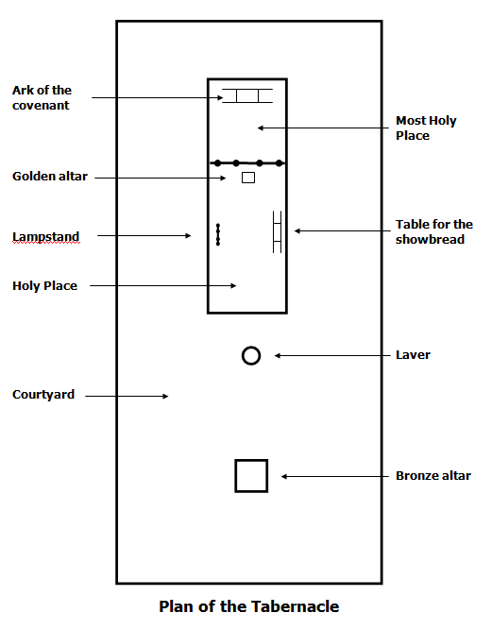

The procedure/ritual

v3 – if the offering is from the herd… – must be male – therefore a bull

Instructions for the worshipper…

- You present
- You lay your hand on the head
  - A prayer? Maybe a prayer of thanksgiving or confession
  - A response by the priest – a song?– e.g. Psalm 20

- You kill the animal (probably by slitting the throat)
- The priests splash the blood on the altar
- You skin the offering and cut it into pieces
- The priests arrange the pieces on the altar
- You wash the internal organs and hind legs
- The priest burns all of it on the altar

Note:
- Active involvement of the worshipper
- Only the holy priest approaches the altar which is considered holy
- The worshipper deals with anything dirty
- Everything gets burnt

v10 – if the offering is from the flock – sheep and goats

v 14 – if an offering of birds – a dove or a young pigeon

v 16 - dealing with the crop (and feathers or contents)
- crop = pouch for storing undigested food – might contain unclean food
- thrown onto the ash heap not burnt on the holy altar

v17 – tear it open, probably to help it burn – but it is to be offered whole

All three offerings create a soothing aroma in the Lord’s nostrils – that’s good; satisfied

Why three sets of instructions/options?

Not all could afford a bull…

Not all could afford a sheep or a goat…

The poorest could bring a bird…

Recognition of economic reality – no financial barriers to the worship of God

But the implication – if you can afford a bull, bring a bull.
- an expensive bull – on without defects

Birds – doesn’t say without blemish – for the poor, no affordability barrier

When were these offerings to be made?

Three main occasions

1. Every day
- morning and evening offerings at the tabernacle – Numbers 28:1-8

2. Special days
- Sabbath – Numbers 28:9-10
- First day of every month – new moon festival – Numbers 28:11-15
- 5 (of the 7) Annual festivals – Numbers 28:16-29:40

3. For purification after more serious uncleanness
- after childbirth (Lev 12)
- after healing from a defiling skin disease (Lev 14)
- after an unusual bodily discharges (Lev 15)

The fire on the altar of burnt offerings was to be kept burning constantly – see Lev 6:8-13
- constant reminder of this need for offerings – smoke always going up
- evening offering to be kept on the fire all night

What was the burnt offering for?

(i) to make atonement

Significance of laying of hands
- a transfer of guilt – 16:21

- identification – this animal is being killed instead of me

v3 and v4 – full of gospel promise

Sin and guilt offering – the issue is specific sins; burnt offering – the problem of sin in general

“The necessity of the atonement is not so much for what we have done or failed to do, but for what we are – we are sinners by nature and disposition as well as practice”

The fire constantly burning – our God is a consuming fire; his holiness threatens to consume us because of our sinfulness

God is holy – the theme of the book – holy people; priests; clothes; utensils; place

Animal after animal had to be slaughtered – the wages of sin is death

(ii) to proclaim the gospel

There is a way of atonement – God has provided that way

Full of promise – but ultimately powerless in themselves to deal once and for all with sin – Heb 10:1-14

Christ comes, not a dumb animal – but a human being, offering a will fully submit to God

Eph 5:2

Eph 4:32

What else did the burnt offering teach?

(i) the cost of our atonement in Christ – 1 Peter 1:18-19

(ii) our worship of God should cost us something

Romans 12:1
Therefore, I urge you, brothers and sisters, in view of God’s mercy, to offer your bodies as a living sacrifice, holy and pleasing to God – this is your true and proper worship.

Questions for reflection

- How do you feel when you read Lev 1:4 and consider the fulfilment of these words In Christ?

- How are you tempted to make defective offerings to God?

- How have you been challenged by the costliness of the burnt offering?

- How are you encouraged by the provision in the law for the poor to offer just a dove or a young pigeon?

