Autumn School: The Disciple-making Parent (Week 2)
Great Commission is for families; parents are the primary teachers and disciple makers – scripturally; statistically
2 Tim 3:14-16 But as for you, continue in what you have learned and have become convinced of, because you know those from whom you learned it, and how from infancy you have known the Holy Scriptures, which are able to make you wise for salvation through faith in Christ Jesus. All Scripture is God-breathed and is useful for teaching, rebuking, correcting and training in righteousness (2 Tim 3:15-16)
Opening Question – how do our children learn... how do they become convinced?
- The power of example
- My walk with the Lord is the most important foundation for good parenting
- I must turn away from serving idols in my heart: my own convenience (laziness): “us/me time”… we’d like to go out / have more sleep… my own pride (obsession): we want people to think we’re a good parent we don’t want to be embarrassed… we want a multi-talented child… My own salvation: Living my life through them, making up for my failures; giving them the opportunities or friendships I never had; making them happy
- Your children are watching you
- Jesus uses teaching and example and models
Very truly I tell you, the Son can do nothing by himself; he can do only what he sees his Father doing, because whatever the Father does the Son also does (John 5:19)
I am reminded of your sincere faith, which first lived in your grandmother Lois and in your mother Eunice and, I am persuaded, now lives in you also. (2 Tim 1:5)
- Sincerity (compared with hypocrisy). Not the same as perfection; effort for consistency, admission of failures
- Living active practical faith with enthusiasm and joy
What might be hurting the witness to my children?
Would your children say you love the Lord or would they just say you are merely “religious?” how could you change that?
Have you ever asked someone to point out a blind spot in your parenting? If not, why not?
If your children are old enough, ask them, “What kinds of things make me excited?” Are you enthusiastic about Jesus, his Word, his kingdom? How does that enthusiasm bubble out onto your children?
Join together in following my example, brothers and sisters, and just as you have us as a model, keep your eyes on those who live as we do. (Philippians 3:17)
- Connecting your children with other examples – spiritual family
- Point to good examples; get them to talk to them if possible
- Talk to them about problems and sin in others: Realistically – there are wrong things, but I sin too
- Discretely – not gossiping; Graciously –repentance & forgiveness as our goal… trusting the gospel
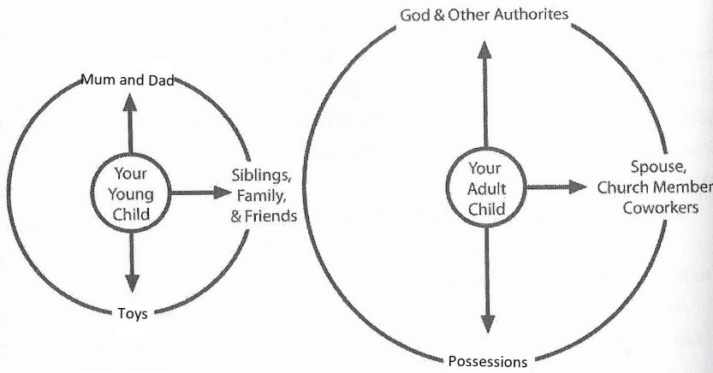
- The power of discipline
- prepare by discipling – obey and honour you so they will know how to obey and honour God
- boundaries are good, safe and re-assuring
- Tenderness and affection – rules and relationship –absence of one or other leaders to rebellion
- Not just behaviour management – making heart connections; motivations, idols, insecurities desires
Have you ever thought that disciplining your child was preparing them to obey God? How does that change your view of discipline?
What is your motive for discipline? A quiet home? The approval of others? A godly adult? How can you more intentionally bring the gospel into your discipline?
- The power of gospel words
- Getting ready ourselves – our children are sinners, need conversion, images of God but fallen
- Speak the gospel: (not all Christians parents feel comfortable doing this)
Sin: not shallow view or they will become hypocritical, ungrateful, lukewarm and self-righteous.
Salvation by grace through the substitutionary work of Christ
Explain the spiritual struggle
Address the heart
- Spontaneous and intentional Time – Breakfast… to bedtime
- Communicate well: don’t over talk or under talk; give time; good listening – eye contact, focus
Fools find no pleasure in understanding but delight in airing their own opinions.(Proverbs 18:2)
The purposes of a person’s heart are deep waters, but one who has insight draws them out. (Prov 20:5)
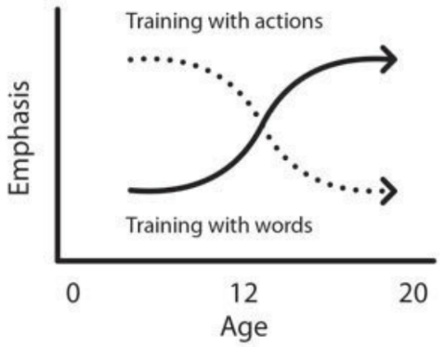
- Younger children need much instruction – training actions, not probing the depths of their hearts why they are having temper tantrums – train in self-control
- It is embarrassing to watch the naïve parent of the four-year-old try to reason with her child. If it is hard to watch the parent reason with a four-year-old, it is equally difficult to watch a parent “talk at” a teen.
- Adjust communication as your child grows has grown. With the older years must come an increased sophistication in our communication.
- Include: encouragement; comfort; urging, warning, rebuke correction
- Offering and asking for forgiveness
For you know that we dealt with each of you as a father deals with his own children, encouraging, comforting, and urging you to live lives worthy of God, who calls you into his kingdom and glory. (1 Thessalonians 2:11-12)
What is the gospel? Take some time and articulate it to someone
- Good questions
Why did you do that?
What would you do if...? What would you say if someone asked you...?
What do your friends think about you going to church?
What do you find annoying about… us… church… someone… life
How do you think I have sinned against you? How do you think you sinned?
What has influenced you to think this way?
This is what I have heard you say. Is that correct? Have I understood you?
What do you think Jesus thinks (and God’s Word says) about...?
Looking back, what do you think you should have done differently?
Think of some of your own?

